Water-soluble aminoacid functionalized perylene diimides: the effect of aggregation on the optical properties in organic and aqueous media

Erika Kozma*, Giorgio Grisci, Wojciech Mróz, Marinella Catellani, Anita Eckstein-Andicsovà, Katiuscia Pagano and Francesco Galeotti

We report on the straightforward preparation and photophysical characterization of four symmetrically substituted water soluble perylene diimides, obtained by functionalizing the imide positions with L-threonine, L-aspartic acid, L-cysteine and L-methionine. The presence of carboxylic groups on the two sides of the aromatic structure conveys water solubility to all the molecules. The combined effect of the hydrophobic perylene core with the specific aminoacidic functionalities leads to different aggregation behaviors in both aqueous and organic media affecting the optical absorption and emission of the aromatic chromophore. By a comparative study of the optical properties we shed light on the main characteristics of these perylene derivatives in organic and aqueous diluted solution. These aminoacid perylene diimide molecules have the potential to be exploited in new sensing applications based on assembly/disassembly-driven fluorescence switching off-on in aqueous media.

Introduction
Stimuli-responsive smart materials can exhibit spectacular changes in their supramolecular organization in response to environmental variations such as light, pH, temperature, chemicals and mechanical stress.1 This fascinating property of self-organization into supramolecules in different solvents is dictated by various non-covalent interactions, such as hydrogen and van der Waals bonding, π-π stacking, solvophobic and electrostatic interactions in suitable solvents.2 Among various building blocks that are able to form supramolecular architectures, perylene diimides (PDIs) are particularly prone to efficiently self-assemble into ordered structures like spheres, rods or vesicles,3-8 due to their rigid, extended aromatic π-core along with their numerous grafting sites.
PDI-based materials, because of their unique spectroscopical and electrochemical properties and their extraordinary chemical, thermal and photostability, PDI-based materials have been used as prominent chromophores in organic solar cells,9-13 field effect transistors,14, 15 light harvesting arrays,16 light-emitting diodes,17, 18 and hybrid WOLEDs.19 To expand the application of PDIs for biological purposes, it is mandatory to improve their solubility in aqueous medium. In fact, their poor solubility in aqueous media is one of the most detrimental factors for using PDI derivatives as fluorescent probes for biosensing applications. This can be achieved by grafting hydrophilic groups to the core of perylene chemical structure (bay positions) or by linking them to the imide positions. The properties and, consequently, the potential application of these amphiphilic perylene structures, possessing both hydrophilic and hydrophobic character, are dictated by their self-association behavior. The intermolecular interactions are especially determined by the ratio between the hydrophilic/hydrophobic components, along with the different steric effects of the substituents. In fact, PDIs normally display poor solubility and very weak fluorescence in aqueous solution because perylene chemical structure typically has a strong tendency to give π-π intermolecular interactions, which consistently decrease both the solubility and emission efficiency. The chemical tailoring of PDI structure can lower or prevent π-π interactions and high fluorescence quantum yields can be obtained by inserting in bay positions sterically hindered substituents and/or charged groups. By this approach, PDIs can be easily tailored for bio-imaging purposes. Müllen and coworkers introduced anionic moieties onto the perylene core, which effectively prevented aggregation through electrostatic shielding and steric hindrance, obtaining high fluorescence quantum yield PDI dyes used as fluorescent labels in living cells.20 A more effective steric hindrance obtained by introducing dendrons in the bay positions, resulting in strongly emmiting PDIs, which were used in target-specific biolabeling.21
On the other hand, water soluble PDIs obtained by functionalizing the imide position preserve the tendency to aggregate with other molecules or with themselves via π-π stacking.22 These interactions are most likely stronger in aqueous media due to the additional hydrophobic effect, which may enhance the transduction of signal in sensing applications. Indeed, these kind of functionalized PDIs are typically used as probes, exploiting the optical response to the assembly-disassembly process (off-on fluorescence) under external stimuli (other molecules, pH, temperature, etc.). Recently Niu and coworkers proposed a PDI derivative containing ionized amino-imidazole groups grafted on the imide positions as sensor for glucose detection, being able to disclose reversible supramolecular structure and fluorescence emission conversion upon pH-stimulation.23 Wang and Yu developed an ultrasensitive biosensor based on an aptamer and a cationic imide substituted PDI for the selective detection of lysozyme.24 The anionic imide substituted water soluble PDIs containing phosphonic acid or carboxylic acid residues as hydrophilic groups, found applications in the detection of DNA’s base-mismatch 25 and of metal ions in aqueous media.26
Among the wide range of possibilities for introducing hydrophilic functional groups in the PDI’s imide position, an intriguing approach is the use of aminoacids. In fact, the amino group of aminoacids can be readily incorporated in the PDI imide structure, exposing both the carboxylic and the specific side-chain group at both ends of perylene towards outside environment. As reported in the literature, only about half of the twenty available standard aminoacids have been incorporated in the perylene imide position to provide water soluble PDIs. In particular, glycine,27 alanine,28 phenylalanine, methionine, leucine,29 lysine,30 tyrosine,31 and aspartic acid 4, 32-34 have been successfully included in the PDI structure and in some cases employed for sensing purposes. Using aminoacid as functional groups, Hirsch group synthesized chiral, water-soluble PDI derivatives having interesting aggregation properties.35 Feng et al. synthesized a PDI derivative with glycyl-l-aspartic acid functional group, able to complex cupric ion.36 The aspartic acid functionalized PDI has already found several applications as “off-on” fluorescent sensor for selective detection of Cu2+ and ATP,32 protease detection and bioimaging.33
In view of the multiple application possibilities of water soluble PDIs in biosensing and metal detection in aqueous media, resulting from the aggregation-deaggregation process, we synthesized four different aminoacid-based perylene diimides (PDI-AAs): PDI-Thr with L-threonine, acid (PDI-Asp with L-aspartic, PDI-Met with L-methionine and PDI-Cys with L-cysteine (Figure 1). Two PDI-AA described in this paper, PDI-Thr and PDI-Cys, have never been described before. We here provide a comparative study and discussion on aggregation behavior both in organic solvent and aqueous medium of the four aminoacid-based perylene diimides by means of absorption and emission spectroscopies. The presence of the aminoacidic carboxylic residues at the peripheral nitrogen atoms allows all the synthesized PDI-AAs to be fully soluble in aqueous medium, while their self-association behavior can be modulated by varying the specific aminoacidic side-chain.As a result, by comparing the optical behavior in DMSO and aqueous medium of L-threonine, L-aspartic acid, L-methionine and L-cysteine derivatives, we shed light on their concentration-dependent aggregation tendency thus opening the path to the development of new PDI-based sensing platforms.

Figure 1. Molecular structures of the perylene diimidesfunctionalized with L-threonine (PDI-Thr), L-aspartic acid (PDI-Asp), L-methionine (PDI-Met) and L-cysteine (PDI-Cys).

Experimental Section
Materials and instruments
Perylene-3,4,9,10-tetracarboxylic dianhydride, imidazole, Zn(OAc)2, L-threonine, L-aspartic acid, L-cysteine, and L-methionine were purchased from Aldrich and used as received without further purification. The PB solution 0.1 M Na2HPO4-NaH2PO4 pH~8.0 was freshly prepared before use with ultrapure water (resistivity about 18.2 MΩ cm at 25 °C) obtained with a Millipore Direct-Q®3 system.
1H-NMR spectra were recorded on Bruker DMX spectrometer operating at 500 MHz. For each PDI-AA sample 1 mg of powder was dissolved in 500 L of phosphate deuterated buffer 30mM at pH 8.0.
FTIR spectra were recorded by a Bruker TENSOR27 spectrophotometer.
Absorption spectra were measured with Perkin Elmer UV/VIS/NIR Lambda 900 spectrometer. PL spectra were recorded with Spex 270M monochromator in conjunction with liquid nitrogen cooled CCD. The light source for PL was monochromated xenon lamp.
Absorption and emission spectra of PDI-AAs in DMSO and phosphate buffer pH 8.0 solutions were obtained by diluting aliquots from the corresponding stock solutions.
General procedure for PDI-AAs
3,4,9,10-Perylene tetracarboxylic acid dianhydride (0.5 mmol), L-aminoacid (1.05 mmol) and 1 g of imidazole were added into a Schlenk and heated at 120 °C for 4 hours. The reaction mixture was cooled and poured into water and filtered. The filtrate was acidified with 2.0 M HCl and the precipitate was filtered and washed with water several times, then with methanol, dried under vacuum to give the final products. Yields: PDI-Thr 89%; PDI-Asp 85%; PDI-Met 87%; PDI-Cys 71%.

Table 1. Electrochemical characteristics of 1.0 mM PDI-AAs in 0.1 M Na2SO4 aqueous solution, scan rate 50 mV/s (V, vs SCE)
E0red1 (V) E1/2red1 (V) Epred1 (V) E0red2 (V) E1/2red2 (V) Epred2 (V)
PDI-Thr -0.30 -0.41 -0.50 -0.64 -0.69 -0.75
PDI-Asp -0.05 -0.20 -0.49 -0.60 -0.69 -0.78
PDI-Met / / / -0.44 -0.62 -0.82
PDI-Cys -0.16 -0.27 -0.38 -0.53 -0.56 -0.61
E0redonset reduction potential; E1/2red halfway reduction potential; Epred peak reduction potential.

N,N’-Bis-(L-Threonine)-3,4,9,10-perylene tetracarboxylic diimide (PDI-Thr)
1H-NMR (500 MHz, D2O Phosphate buffer 30mM pH 8.0, ppm): 8.54-7.16 (8H, pery), 5.6 (1H, Thrβ), 5.2 (1H, Thrα), 1.89-1.17 (3H, Thrγ).
FTIR (KBr, cm-1): 1696, 1654 (imide), 1591 (arom), 1401, 1363 (C-H).
N,N’-Bis-(L-Aspartic acid)-3,4,9,10-perylene tetracarboxylic diimide (PDI-Asp)
1H-NMR (500 MHz, D2O Phosphate buffer 30mM pH 8.0, ppm): 8.17-7.9 (8H, pery), 5.9-6.17 (1H, Asp α), 3.20-3.04 (2H, Asp β).
FTIR (KBr, cm-1): 1696, 1654 (imide), 1591 (arom), 1401, 1363 (C-H).
N,N’-Bis-(L-Methionine)-3,4,9,10-perylene tetracarboxylic diimide (PDI-Met)
1H-NMR (500 MHz, D2O Phosphate buffer 30mM pH 8.0, ppm): 7.62-7.37 (8H, pery), 5.43 (1H, Met α), 2.72-2.67 (2H Met γ), 2.40 (2H, Met β),2.23 (3H, Met CH3).
FTIR (KBr, cm-1): 1696, 1654 (imide), 1591 (arom), 1401, 1363 (C-H).
N,N’-Bis-(L-Cysteine)-3,4,9,10-perylene tetracarboxylic diimide (PDI-Cys)
1H-NMR (500 MHz, D2O Phosphate buffer 30mM pH 8.0, ppm): 7.91-7.54 (8H, pery), 6.32-5.95 (1H, Cysα), 3.90-3.66 (2H, Cysβ).
FTIR (KBr, cm-1): 1696, 1654 (imide), 1591 (arom), 1401, 1363 (C-H).
Results and discussion
The synthesis of the four PDI-AAs from the corresponding anhydride is straightforward and afforded these symmetrically aminoacid-substituted dyes in good yield (70-90%). As shown in Scheme 1, PDI-AAs were obtained by heating at 120 °C the starting material perylene-3,4,9,10-tetracarboxylic dianhydride and the corresponding L-aminoacid in imidazole. The functionalization was completed in 4h for all derivatives, except for reaction with L-cysteine (Cys) which produced also a small amount of mono-substituted derivative, easily removed by column chromatography. All these dyes were found to be completely soluble both in organic (DMSO) and aqueous environment. Thus, they can be regarded as symmetric bola-amphiphilic molecules in which the hydrophilic heads are separated by the hydrophobic perylene core. The short side chains contain a carboxylic group, accompanied by a different functional residue specific for each aminoacid: hydroxyl (PDI-Thr), carboxyl (PDI-Asp), thioether (PDI-Met) and thiol (PDI-Cys).

Scheme 1.General synthetic procedure for the preparation of PDI-AAs.

This common structure was elucidated by performing spectroscopy analysis. PDI-AAs IR pattern has the typical bands of the disubstituted PDIs at 1698 and 1658 cm-1, characteristic for the imidic groups, attesting the successful insertion of the aminoacid moiety into the perylene structure (see ESI-1). The four PDI-AAs were also characterized by 1H NMR: the typical pattern of the perylene protons resonances, and the proton resonances of each of the four aminoacids were identified (ESI-2), confirming also the purity of the synthesized dyes. The large line widths mirror the tendency towards aggregation of the conjugate aromatic ring.
The redox behavior of PDI-AAs was analyzed by cyclic voltammetry (see ESI-3). Table 1 shows the reduction potentials in 0.1 M Na2SO4 aqueous solution. Under these conditions, each PDI-AA undergoes quasi-reversible reduction events and none shows any oxidative activity in the scan range. The half way potentials were determined from the cyclic voltammograms, corresponding to the formation of the monoanion radical (E1/2red1) and the dianion (E1/2red2). In all cases both peaks were detectable, except PDI-Met first reduction peak; the reduction potentials are all in the same range and in line with previously published data for similar compounds.37 To shed light on the aggregation behavior of PDI-AAs in different media, we carried out concentration dependent UV-Vis and photoluminescence (PL) comparative studies in DMSO and in aqueous environment. Because the spectroscopic properties of the carboxylic acid derivatives strongly depend on pH, the choice of a suitable buffer is crucial. The –COOH residues grafted at the imide positions of our PDI derivatives have pKa= 4.70 for β-hydroxybutyric acid (PDI-Thr), pKa1 =4.21 and pKa2 =5.64 for succinic acid (PDI-Asp), pKa= 3.66 for 4-methylthiobutyric acid (PDI-Met) and pKa= 4.87 for 3-mercaptopropionic acid (PDI-Cys).38, 39 Although the pKa values listed above are characteristic for the single carboxylic acids, we have assumed that the variations rising from the presence of the perylene core are negligible. If the pH of the solution is lower than pKa then the carboxylic acids will be in protonated form, while they will be deprotonated for pH higher than pKa. On these bases, considering both the solubility and the pKavalues, we have selected phosphate buffer (PB) at pH 8.0 as the common aqueous medium for our study. The slightly basic medium provides fully deprotonated –COOH groups, which promote electrostatic repulsions between the PDI molecules and thus guaranteeing a fairly good solubility. In addition, working in a pH close to the physiological one is appealing for possible applications in biosensing.

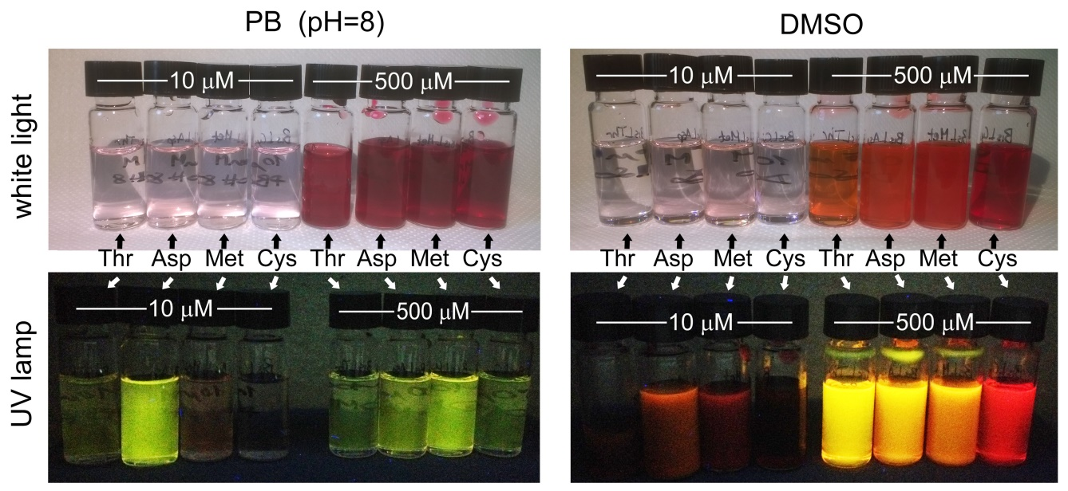
Figure 2. Visual comparison of solutions of the four PDI derivatives in PB and DMSO at two different concentrations, observed under white light and under the UV lamp (λ = 345 nm).

In all the analyzed solutions, the concentration was kept between 5 and 500 μM; the latter concentration was chosen as the general upper limit for getting transparent solutions. As shown in Figure 2, under ambient light all the PDI-AAs appear as colored transparent solutions going from light pink to dark red in PB and from light pink to dark orange in DMSO, depending on the concentration. At the highest concentration, some samples show a little turbidity due to formation of big aggregates. Under the UV lamp (λ = 345 nm), the same samples clearly show variability in both color and intensity of emission, suggesting differences in their aggregation behavior.Typically, perylene dyes obtained through condensation reaction at the imide positions are characterized by absorption and emission features which are independent from the peripheral functional groups, due to the presence of nodes in the HOMO and LUMO at the imidic nitrogen, which prevent the electronic coupling between the perylene core and the imide substituents.3 When PDI molecules are in a non-aggregated form, which is the case of highly soluble derivatives in diluted organic solutions, the absorption spectra show bands in the range of 450-550 nm ascribable to the S0-S1 transition of the PDI chromophore, with three pronounced, well-defined vibronic structures. These structures are attributed to breathing vibrations of the perylene core which couples with the S0-S1 transition polarized along the long axis of the molecule.40 A fascinating feature of the perylene chromophores in solutions is the dramatic intensity reversal between the 0→0 (around 550 nm) and 0→1 (around 500 nm) vibronic absorption bands upon π-π stacking. This distinct spectral property can be used to provide insight into the degree of aggregation in solution. While aggregation phenomena of PDIs have been extensively studied in organic solvents, studies describing these phenomena in aqueous media are quite limited.
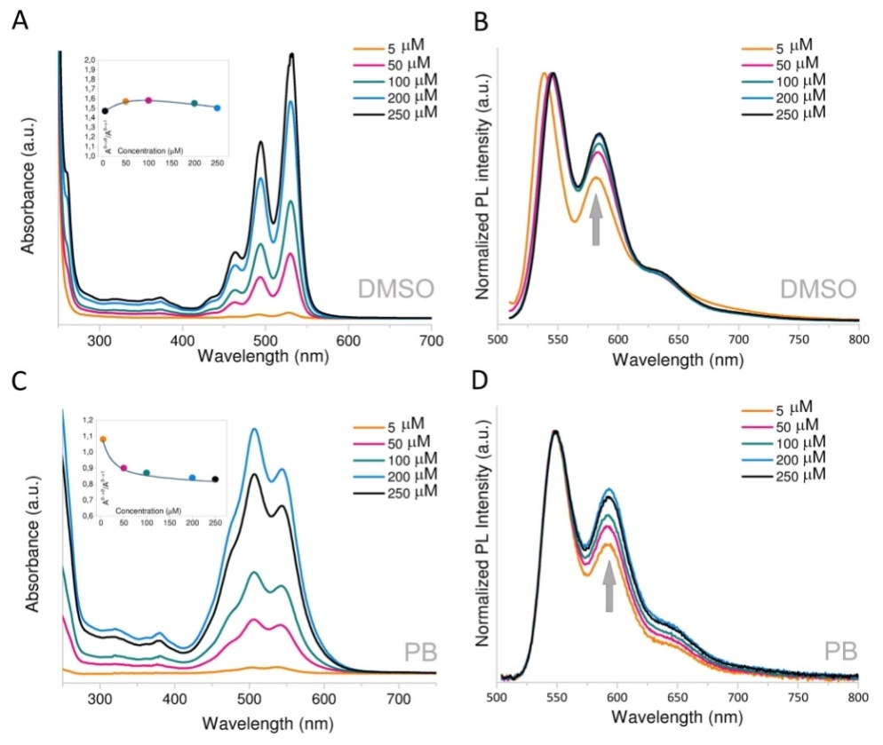

Figure 3. Spectroscopical data for PDI-Thr. Concentration-dependent UV-Vis absorption (A) and fluorescence (B) spectra in DMSO. Concentration-dependent UV/vis absorption (C) and fluorescence (D) spectra in phosphate buffer pH 8.0; fluorescence excitation wavelength is λexc 500 nm. Inset: concentration-dependent absorption ratio (A0→0/ A0→1) trend.

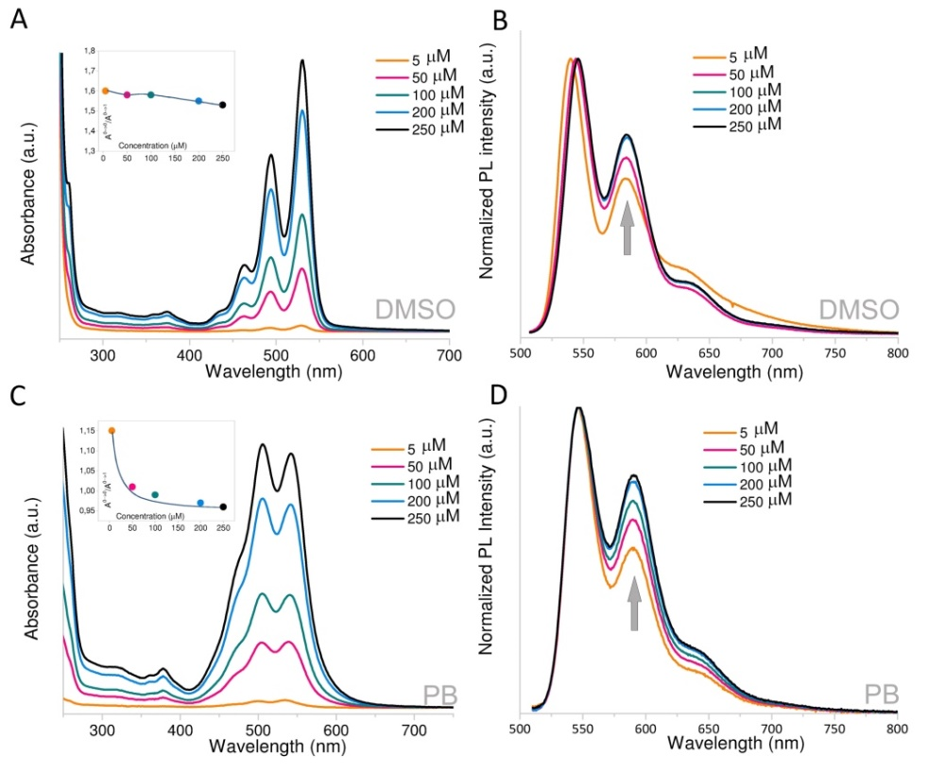
Figure 4.Spectroscopical data for PDI-Asp.Concentration-dependent UV-Vis absorption (A) and fluorescence (B) spectra in DMSO.Concentration-dependent UV/vis absorption (C) and fluorescence (D) spectra in phosphate buffer pH 8.0; fluorescence excitation wavelength is λexc 500 nm. Inset: concentration-dependent absorption ratio (A0→0/ A0→1) trend.
The photophysical properties of PDI-AAs substantially depend on the environment: in the aqueous medium their tendency of forming aggregates is more pronounced, while they remain in almost monomeric form in less polar media, such as DMSO. The absorption and emission spectroscopic analysis on the four PDI-AAs solution will be here discussed comparing PDI-Thr with PDI-Asp and PDI-Met with PDI-Cys due to chemical structural similarities.
Figures 3 and 4 show the concentration dependent absorption and emission spectral changes for PDI-Thr and PDI-Asp. For both molecules, the UV-Vis spectra in DMSO solution (Fig. 3A and Fig. 4A) show well-resolved vibronic absorption bands, with three peaks at around 460 nm, 490 nm and 530 nm, typical of the molecularly dissolved PDI, characterized by the usual vibrational progression with A0→0/ A0→1 ≈1.6. This ratio undergoes small variations by increasing the concentration from 50 μM to 250 μM; for both PDIs a slight decrease at the higher concentrations can be noticed, which is an indication of a weakly aggregated state (Figures 3A and 4A insets). These findings are in line with the corresponding PL spectra, which are shown in panels B of Figures 3 and 4 as normalized plots to highlight the differences in the spectral profile. The normalized spectra reveal a small increase of the band centered around 585 nm in respect to the maximum peak at ≈545 nm as concentration increases from 5 to 50 μM; then the two bands essentially maintain a constant ratio. The red-shift 5-7 nm in the maximum peak, recorded for both PDI-Thr and PDI-Asp when concentration varies from 5 to 50 μM, is attributable to increased self-absorption. The above data suggest that both PDIs reflect an almost monomeric, non-aggregated form in DMSO solution.

Table 2. Absorption ratios A0→0/ A0→1 of PDI-AAs at different concentrations in phosphate buffer solution (pH 8.0) and DMSO
A0→0/ A0→1
5 μM A0→0/ A0→1
50 μM A0→0/ A0→1
100 μM A0→0/ A0→1
200 μM A0→0/ A0→1
250 μM
PDI-Thr PB 1.08 0.90 0.87 0.83 0.84
DMSO 1.47 1.57 1.58 1.55 1.50

PDI-Asp PB 1.15 1.01 0.99 0.97 0.97
DMSO 1.60 1.58 1.58 1.55 1.53

PDI-Met PB 0.92 0.84 0.83 0.82 0.82
DMSO 1.54 1.39 1.36 1.48 1.47

PDI-Cys PB 0.85 0.86 0.87 0.87 0.88
DMSO 1.40 0.89 0.91 0.94 0.94

The spectroscopical differences between buffer solution and organic medium are clearly evident for PDI-Thr and PDI-Asp. The absorption spectra of PB solutions (panels C of Figures 3 and 4) show a broad structured band, from 410 nm up to 625 nm. The well-resolved vibrational features in DMSO become less structured in aqueous solution, symptomatic of a predominantly assembled state. Indeed, PDI-Thr and PDI-Asp molar extinction coefficients have lower intensity in PB solution for concentrations between 5 and 250 μM (see ESI-4) and the spectra show only two absorption bands at ≈540 nm and 505 nm bathochromically shifted with respect to those in DMSO. The absorption ratios display an inverted intensity distribution among these bands, with A0→0/ A0→1 ≈0.9 for PDI-Thr and ≈1.0 for PDI-Asp, while for very diluted solutions (5 μM) this ratio is slightly bigger than unity (Table 2). The observed peak inversion is clear evidence that the two PDI-AA dyes in the aqueous medium tend to aggregate as concentration increases.
Fluorescence measurements further confirmed this behavior. The PL normalized spectra in buffer solution show peaks centered at 548 and 593 nm for PDI-Thr and at 547 and 591 nm for PDI-Asp (panels D of Figures 3 and 4, respectively). The PL feature has the same spectral pattern in DMSO and buffer solution, but slightly red-shifted in aqueous media. Moreover the intensity of the second band linearly increase with concentration, indicating the gradual formation of the aggregation state.
By comparing both the PL spectra (Figures 3 and 4) and the absorption ratio data reported in Table 2, we can observe that in PB solution PDI-Thr is slightly more aggregated than PDI-Asp, although, in these pH conditions, both molecules contain deprotonated carboxylic groups, which should induce electrostatic repulsions. Such difference could be explained by the involvement of PDI-Thr hydroxyl groups in hydrogen bond formation, which may induce a higher tendency to aggregation in aqueous solution. The same trend is shown by fluorescence quantum yields (ΦF) of PDI-Thr and PDI-Asp 5 μM aqueous solutions, which are 0.24 and 0.54, respectively (Table 3). This is a further indication that, at this concentration, in PDI-Asp the fluorescence quenching mechanism due to aggregation is less efficient than in PDI-Thr. The ΦF values measured for PDI-Thr and PDI-Asp are pretty high if compared to those reported for analogous dendronized derivatives, where aggregation is limited by sterical hindrance.41, 42 The fluorescence quantum yields of aggregated molecules strongly depends on concentration and therefore a direct comparison with literature data is not feasible unless measured in the same conditions.
Compared to the above discussed data, the spectroscopical properties of PDI-Met and PDI-Cys, both containing sulfur atoms, show some interesting differences (Figures 5 and 6). In DMSO solution, PDI-Met absorption and emission spectra look similar to the previous discussed PDI-AAs, with slightly lower values of absorption ratio indicating a quasi-disaggregated state (Figure 5A-B). The inversion of the PL intensity trend observed passing from 200 to 250 μM is due to the reaching the solubility limit in DMSO for this material, with appearance of some turbidity in the solution sample. By contrast, the trend of PDI-Cys absorption ratios is completely different (Figure 6A).
Table 3. Photophysical characteristics of PDI-AAs 5 μM solutions in phosphate buffer (pH 8.0) and DMSO
solvent λabsmax
(nm) λemmax
(nm) εmax
(M-1 cm-1) ΦFa
PDI-Thr PB 506 548 26140 0.24
DMSO 530 545 101160
PDI-Asp PB 507 547 30240 0.54
DMSO 529 544 85890
PDI-Met PB 511 595 34450 0.09
DMSO 532 540 61740
PDI-Cys PB 512 710 11690 0.002
DMSO 505 663 36590
aThe quantum yield (ΦF) was measured relative to the rhodamine 6G solution in ethanol.
For the most diluted solution (5 μM), a weak aggregated state can be noticed, with the absorption ratio of 1.40. As concentration increases beyond 50 μM the UV-Vis spectra lose sharpness and are characterized by a gradual red-shift. Since DMSO is known to be a weak oxidant for the –SH groups in peptides,43 we can imagine that for PDI-Cys, besides the typical π-π stacking interactions, disulfide bonds could be formed leading to different aggregation states.
Also the shape of PDI-Cys PL spectrum completely changes as concentration increases beyond 5 μM, gradually losing the spectral pattern attributable to the monomeric state and displaying a new broad peak centered around 650-660 nm (Figure 6B). This new emission band has a very large Stokes shift (about 120 nm) and can be ascribed to excimer state formation. Planar aromatic compounds, in fact, can form excimers when an excited-state molecule is brought in close proximity to another ground-state molecule, and excimer emission band has been already reported for PDIs and exploited in sensing applications.25, 44-46 In analogy of what recently described by Würthner group, by comparing the absorption and emission spectra, we can speculate that upon photoexcitation we are in the presence of two different kinds of excited states: noncovalent dimers, that are responsible for the decrease of the absorption ratio when concentration increases, and excimers, which are responsible for the red-shifted emission.44 The fact that, among the four PDI-AAs under investigation, we observed the excimer emission only for PDI-Cys, suggests that the –SH groups play a role also in the excimer formation.
The photophysical behavior of PDI-Met and PDI-Cys in PB solution, shown in Figure 5C-D and 6C-D, respectively, resemble that of highly aggregated materials. For both molecules in fact, the inversion of the maximum absorption intensities does not occur and the peak ratio remains below the unit value for all the concentrations tested. This is a peculiar behavior and suggests well-established aggregation states. Given the totally different trend previously observed for PDI-Thr and PDI-Asp, we can ascribe this behavior to the presence of the sulfur containing groups.
The PL spectra shown in Figure 5D and Figure 6D confirm the presence of aggregated states for both PDI-Met and PDI-Cys, but their patterns are different. PDI-Met shows a broad almost featureless emission band centered at 600 nm, which is consistent with a greatly aggregated state. The intensity of this band is concentration dependent, while its shape is not affected by concentration. On the contrary, PDI-Cys PL spectrum reveals a clear concentration dependent progress of the two peaks at 549 and 595 nm and of a broad, red-shifted band centered at 720 nm, which appears as concentration increases beyond 5 μM. The vibronic structure of the green edge of the emission spectrum is attributed to the monomeric form, which progressively disappears as concentration rises, while the 720 nm peak characteristic of excimer state formation emerges. The very low ΦF (0.09 and 0.002, respectively), recorded for PDI-Met and PDI-Cys at the concentration of 5 μM (Table 3), is consistent with the presence of highly aggregated states (quenched emission) and with a limited formation of excimers.

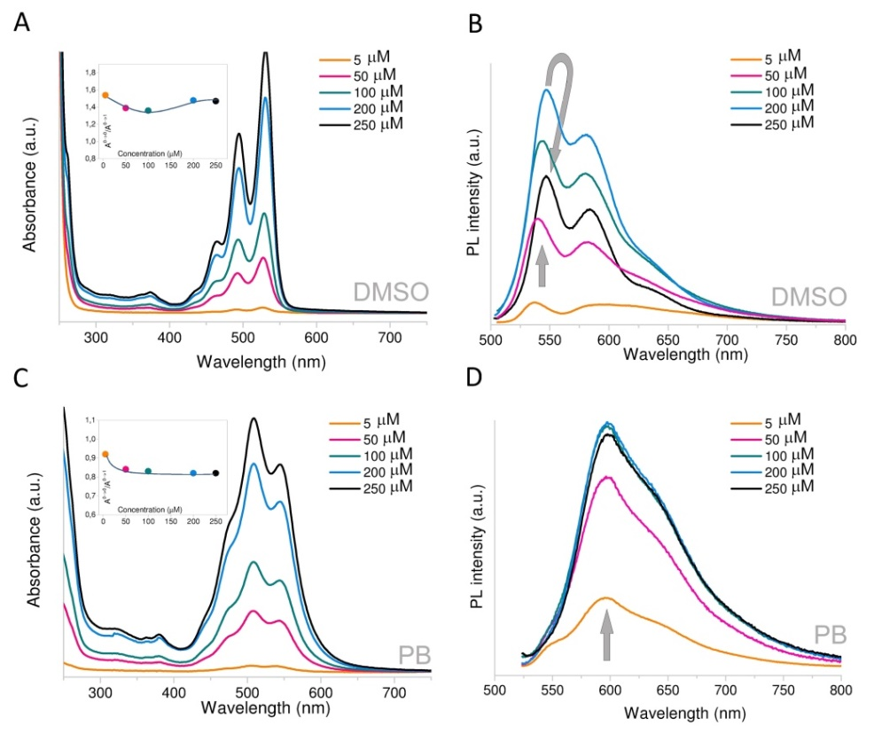
Figure 5.Spectroscopical data for PDI-Met.Concentration-dependent UV-Vis absorption (A) and fluorescence (B) spectra in DMSO. Concentration-dependent UV/vis absorption (C) and fluorescence (D) spectra in phosphate buffer pH 8.0; fluorescence excitation wavelength is λexc 500 nm. Inset: concentration-dependent absorption ratio (A0→0/ A0→1) trend.

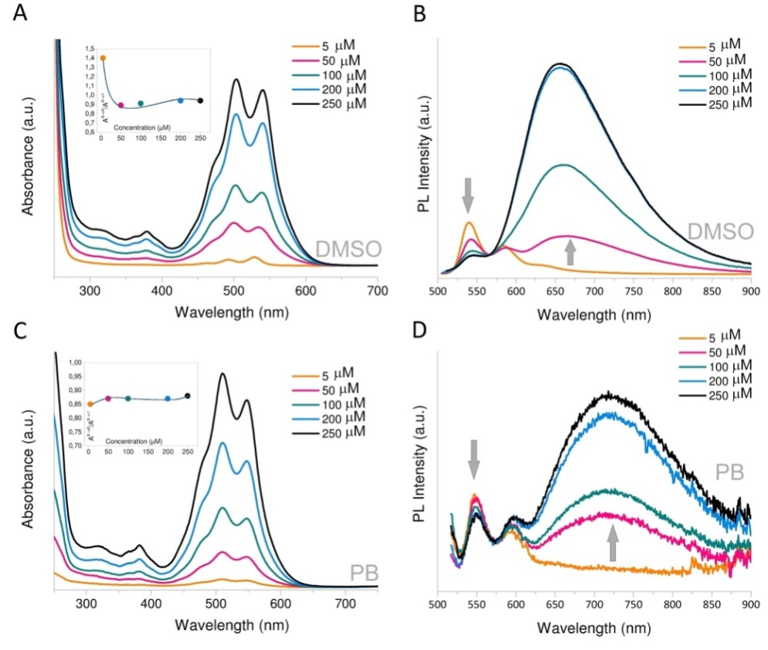
Figure 6.Spectroscopical data for PDI-Cys.Concentration-dependent UV-Vis absorption (A) and fluorescence (B) spectra in DMSO. Concentration-dependent UV/vis absorption (C) and fluorescence (D) spectra in phosphate buffer pH 8.0; fluorescence excitation wavelength is λexc 500 nm. Inset: concentration-dependent absorption ratio (A0→0/ A0→1) trend.

Conclusions
We have synthesized four different water soluble aminoacid functionalized perylene diimides, PDI-AA, by the straightforward insertion of L-threonine, L-aspartic acid, L-cysteine and L-methionine in the imide perylene positions. Two PDI-AA described in this paper, PDI-Thr and PDI-Cys, have never been described before. We have demonstrated that the optical absorption and emission properties of these materials in diluted solution are highly affected by their aggregation behaviour. By comparative concentration dependent photophysical study in organic solvent and aqueous buffer at pH 8.0 we have highlighted some peculiar characteristics. In particular in buffer medium, PDI-Thr and PDI-Asp undergo to absorption peak inversion and gradual PL quenching, due to molecular aggregation, when concentration increases from 10μM to 250 μM. PDI-Cys in aqueous buffer solution displays the typical excimer emission band which intensity grows with the concentration increasing. Remarkably, we have measured ΦF for PDI-Thr and PDI-Asp as high as 24% and 54% respectively, for 5 μM buffer solutions, which is a promising basis for the development of sensing methods based on photoluminescence response. The spectroscopical comparative study on PDI-AA was conducted at pH close to the physiological conditions to investigate these materials for possible applications in biosensing.
The here reported result constitute a promising platform for the exploitation of PDI-AAs as active probes in metal detection and biosensing applications in aqueous media.
Acknowledgments
This work has been supported by AccordoQuadro betweenRegioneLombardia and CNR – Cluster Project ‘Energy’ n°17348, and by Progetto Cariplo Edonhist n°2012-0844. G.G and K.P. thank Fondazione Antonio De Marco for financial support.
References
1. D. Roy, J. N. Cambre and B. S. Sumerlin, Prog Polym Sci, 2010, 35, 278-301.
2. E. Mattia and S. Otto, Nat Nanotechnol, 2015, 10, 111-119.
3. F. Wurthner, Chem Commun, 2004, 1564-1579.
4. Y. Gao, H. Li, S. Yin, G. Liu, L. Cao, Y. Li, X. Wang, Z. Ou and X. Wang, New J Chem, 2014, 38, 5647-5653.
5. X. Liu, Y. Zhang, X. Pang, Y. E, Y. Zhang, D. Yang, J. Tang, J. Li, Y. Che and J. Zhao, The Journal of Physical Chemistry C, 2015, 119, 6446-6452.
6. A. Arnaud, J. Belleney, F. Boué, L. Bouteiller, G. Carrot and V. Wintgens, Angewandte Chemie, 2004, 116, 1750-1753.
7. X. Zhang, S. Rehm, M. M. Safont-Sempere and F. Würthner, Nat Chem, 2009, 1, 623-629.
8. K. V. Rao and S. J. George, Chemistry – A European Journal, 2012, 18, 14286-14291.
9. W. Jiang, L. Ye, X. G. Li, C. Y. Xiao, F. Tan, W. C. Zhao, J. H. Hou and Z. H. Wang, Chem Commun, 2014, 50, 1024-1026.
10. J. Zhao, Y. Li, H. Lin, Y. Liu, K. Jiang, C. Mu, T. Ma, J. Y. Lin Lai, H. Hu, D. Yu and H. Yan, Energy & Environmental Science, 2015, 8, 520-525.
11. X. Zhang, Z. H. Lu, L. Ye, C. L. Zhan, J. H. Hou, S. Q. Zhang, B. Jiang, Y. Zhao, J. H. Huang, S. L. Zhang, Y. Liu, Q. Shi, Y. Q. Liu and J. N. Yao, Adv Mater, 2013, 25, 5791-5797.
12. E. Kozma and M. Catellani, Dyes Pigments, 2013, 98, 160-179.
13. E. Kozma, D. Kotowski, S. Luzzati, M. Catellani, F. Bertini, A. Famulari and G. Raos, Rsc Adv, 2013, 3, 9185-9188.
14. S. H. Kim, Y. S. Yang, J. H. Lee, J.-I. Lee, H. Y. Chu, H. Lee, J. Oh, L.-M. Do and T. Zyung, Optical Materials, 2003, 21, 439-443.
15. R. T. Weitz, K. Amsharov, U. Zschieschang, E. B. Villas, D. K. Goswami, M. Burghard, H. Dosch, M. Jansen, K. Kern and H. Klauk, Journal of the American Chemical Society, 2008, 130, 4637-4645.
16. K. M. Lefler, C. H. Kim, Y.-L. Wu and M. R. Wasielewski, The Journal of Physical Chemistry Letters, 2014, 5, 1608-1615.
17. L. Li, M. Guan, G. Cao, Y. Li and Y. Zeng, Applied Physics A, 2010, 99, 251-254.
18. F. J. Cespedes-Guirao, S. Garcia-Santamaria, F. Fernandez-Lazaro, A. Sastre-Santos and H. J. Bolink, J Phys D Appl Phys, 2009, 42.
19. E. Kozma, W. Mróz and F. Galeotti, Dyes Pigments, 2015, 114, 138-143.
20. A. Margineanu, J. Hofkens, M. Cotlet, S. Habuchi, A. Stefan, J. Q. Qu, C. Kohl, K. Mullen, J. Vercammen, Y. Engelborghs, T. Gensch and F. C. De Schryver, J Phys Chem B, 2004, 108, 12242-12251.
21. S. K. Yang, X. H. Shi, S. Park, S. Doganay, T. Ha and S. C. Zimmerman, Journal of the American Chemical Society, 2011, 133, 13206-13206.
22. D. Görl, X. Zhang and F. Würthner, Angewandte Chemie International Edition, 2012, 51, 6328-6348.
23. W. Zhang, S. Y. Gan, F. H. Li, D. X. Han, Q. X. Zhang and L. Niu, Rsc Adv, 2015, 5, 2207-2212.
24. B. Wang and C. Yu, Angew Chem Int Edit, 2010, 49, 1485-1488.
25. D. Baumstark and H. A. Wagenknecht, Angew Chem Int Edit, 2008, 47, 2612-2614.
26. A. K. Dwivedi, M. Pandeeswar and T. Govindaraju, Acs Appl Mater Inter, 2014, 6, 21369-21379.
27. W. E. Ford, Journal of Photochemistry, 1987, 37, 189-204.
28. R. K. Sun, C. M. Xue, M. Owak, R. M. Peetz and S. Jin, Tetrahedron Lett, 2007, 48, 6696-6699.
29. R. F. Araujo, C. J. R. Silva, M. C. Paiva, M. M. Franco and M. F. Proenca, Rsc Adv, 2013, 3, 24535-24542.
30. Y. Sun, Z. B. Li and Z. H. Wang, J Mater Chem, 2012, 22, 4312-4318.
31. S. Roy, D. K. Maiti, S. Panigrahi, D. Basak and A. Banerjee, Rsc Adv, 2012, 2, 11053-11060.
32. L. Zhong, F. F. Xing, Y. L. Bai, Y. M. Zhao and S. R. Zhu, Spectrochim Acta A, 2013, 115, 370-375.
33. Y. Y. Lin, R. Chapman and M. M. Stevens, Anal Chem, 2014, 86, 6410-6417.
34. P. K. Sukul, P. K. Singh, S. K. Maji and S. Malik, Journal of Materials Chemistry B, 2013, 1, 153-156.
35. C. D. Schmidt, C. Bottcher and A. Hirsch, Eur J Org Chem, 2009, 5337-5349.
36. X. L. Feng, Y. X. An, Z. Y. Yao, C. Li and G. Q. Shi, Acs Appl Mater Inter, 2012, 4, 614-618.
37. L. N. Zhong, F. F. Xing, W. Shi, L. M. Yan, L. Q. Xie and S. R. Zhu, Acs Appl Mater Inter, 2013, 5, 3401-3407.
38. D. D. Perrin, B. Dempsey and E. P. Serjeant, pKa prediction for organic acids and bases, Springer, 1981.
39. A. Albert, The determination of ionization constants: a laboratory manual, Springer Science & Business Media, 2012.
40. M. Sadrai, L. Hadel, R. R. Sauers, S. Husain, K. Krogh-Jespersen, J. D. Westbrook and G. R. Bird, The Journal of Physical Chemistry, 1992, 96, 7988-7996.
41. B. Gao, H. Li, H. Liu, L. Zhang, Q. Bai and X. Ba, Chem Commun, 2011, 47, 3894-3896.
42. T. Heek, C. Fasting, C. Rest, X. Zhang, F. Wurthner and R. Haag, Chem Commun, 2010, 46, 1884-1886.
43. J. P. Tam, C. R. Wu, W. Liu and J. W. Zhang, Journal of the American Chemical Society, 1991, 113, 6657-6662.
44. M. Son, K. H. Park, C. Shao, F. Würthner and D. Kim, The Journal of Physical Chemistry Letters, 2014, 5, 3601-3607.
45. Y. Wang, J. Chen, Y. Chen, W. Y. Li and C. Yu, Anal Chem, 2014, 86, 4371-4378.
46. J. K. Muraih, J. Harris, S. D. Taylor and M. Palmer, Biochimica et Biophysica Acta (BBA) - Biomembranes, 2012, 1818, 673-678.

