Molecularly imprinted polymer for selective adsorption of diclofenac from contaminated water
Maria Cantarella ^{a*}, Sabrina C. Carroccio ^{a,b}, Sandro Dattilo ^{b}, Roberto Avolio ^{c}, Rachele Castaldo ^{c}, Concetto Puglisi ^{b}, Vittorio Privitera ª
ª CNR-IMM, Via S. Sofia 64, 95123 Catania, Italy
^{b} CNR-IPCB, Via Paolo Gaifami 18, 95126 Catania, Italy
^{c} CNR-IPCB, Via Campi Flegrei 34, 80078 Pozzuoli (NA), Italy

*Corresponding author
E-mail address: maria.cantarella@ct.infn.it (M. Cantarella)

Abstract
The presence of pharmaceuticals, such as non-steroidal anti-inflammatory drugs (NSAIDs) in the aquatic environment represents a worldwide threat. NSAIDs are considered “emerging contaminants” of water since the traditional methods are not designed to efficiently remove them. Aiming to overcome the limits of the conventional wastewater treatment plants, we propose molecularly imprinted polymers (MIPs) as valid tools for selective adsorption and removal of these drugs from water. In particular, in this work, we have prepared diclofenac-selective MIP by a simple bulk polymerization process. After the characterization of the synthetized polymers, the binding abilities were evaluated in detail through the adsorption of diclofenac in aqueous solution and compared with the abilities of a corresponding non-imprinted polymer used as a reference. Thanks to the imprinting effect, the prepared MIP adsorbs with extreme selectivity its template molecule, i.e. the diclofenac. This effect was evaluated by testing the adsorption abilities towards different drugs, such as acetylsalicylic acid and trimethoprim. In addition, MIP reusability was demonstrated after a simple regeneration step. The strength of this work is due to the low cost synthesis of MIP and to its optimal performance of molecular recognition in water, differentially from many of the traditional MIPs, usually used with organic solvent. Such peculiarities make the material potentially applicable for water treatment on a large scale.

KEYWORDS: molecularly imprinted polymers; water treatment; emerging contaminants, diclofenac; selective adsorption; non-steroidal anti-inflammatory drugs.

1. Introduction
Nowadays, the contamination of water resources due to new industrial and human activities is becoming more and more dramatic, posing a serious threat for human health. A lot of organic substances, such as human pharmaceuticals, veterinary medicines, personal care products, have been recently detected in surface water, groundwater, and also drinking water [1]. These new emerging pollutants are considered very dangerous, even if in traces, because they could provoke severe ecological side effects. For this reason, water pollution by these compounds is becoming a subject of global concern attracting significant interest among the major international organizations such as World Health Organization, United States Geological Survey, United States Environmental Protection Agency and the European Commission [2].
Among the several emerging pollutants, non-steroidal anti-inflammatory drugs (NSAIDs), in particular diclofenac, are the most common compounds detected in environmental compartments due to their large consumption throughout the world. It has been demonstrated that extended exposure even at low concentration to this drug may lead to chronic toxicological effects, and some studies suspected that some diclofenac metabolites might be potentially more toxic than the parent compound. In addition, diclofenac can interact with other inorganic or organic contaminants of wastewater matrix producing more dangerous compounds [3]. Diclofenac and the other NSAIDs enter the environment via anthropogenic activities and have been detected in surface water, groundwater and even drinking water. Their main sources are the effluents from the traditional municipal wastewater treatment plants which are unable of treating such substances at very low concentrations (typically in micro- or nano-gram per liter) [4,5]. In light of this, the implementation of the traditional systems with innovative and more specific methods to remove selectively this new type of contaminants from water is urgently needed [6,7].
Currently, the literature reports the use of molecularly imprinted polymers (MIPs) as a promising approach for the removal of trace pollutants from water. The molecular imprinting technique is an emerging technology in which the synthesis of a material is performed in the presence of a template molecule; the subsequent removal of the template provides a material with “memory” sites able to selectively recognize and rebind the original template from a mixture [8-10]. MIPs have attracted considerable scientific interest in the field of solid-phase extraction, sensors, catalysts, enzyme mimics, receptors and antibodies [11-14]. Recently, the molecular imprinting technique has been used in environmental applications for the preconcentration and selective removal of pollutants. Adsorption is indeed one of the most used and efficient method for the removal of both inorganic and organic pollutants from water. To date, several adsorbents have been developed, including activated carbons, clays, chitosan, etc. However, despite their excellent adsorption performances, they are not selective and in any case they are not able to remove organic contaminants in traces. In addition, the commercial activated carbon, that is the most popular adsorbent for water treatment is relative expensive due to the high production cost, high regeneration cost requiring high-pressure stream and 10-15% loss in the reactivation procedure [15].
The main advantages of the MIPs are represented by the ease of preparation and by the possibility to create “tailor-made” binding sites simply by adapting the synthesis procedure for the desired target molecule used as template during the polymerization [16,17]. These systems overcome many problems of the traditional methods, being low cost, with low energy consumption and environmental impact as well [18-20]. The increasing number of works about the use of MIPs for water treatment demonstrates the potentiality of this approach. For example, MIP was successfully applied to remove: dyes [21], estrogens [22], pesticides [23], personal care products [24], pharmaceutical products like NSAIDs [25]. Regarding the latter point, the scientific community has extensively drawn its attention on MIPs formulation prepared by using NSAIDs as a template. The precipitation polymerization is the most used method to synthetize the imprinted material, being the main drawback related to such kind of polymerization derived from the complexity and number of steps needed to obtain the material; consequently, they are time and solvent consuming [26-31]. In addition, the swelling ratio of MIP in water is often completely different from the swelling in the organic solvent in which it was prepared, making the MIP unable to distinguish the target compounds from non-target ones [20]; as well as if the affinity of the polymer with water is not good, the binding capacities of the polymer could be drastically reduced. All these concerns make the choice of the reagents, and in particular of the functional monomer, a key factor to achieve high performance materials [21,32].
Aim of this work was to achieve an imprinted material with high and selective adsorption capacity towards diclofenac, using an easier and quick synthetic procedure, if compared to the methods reported in the literature. We have prepared a MIP by a single-step bulk polymerization process, and in order to obtain a very efficient material in water, we have chosen the methacrylic acid as functional monomer. The synthetized materials were characterized by thermogravimetry (TG), pyrolysis gas chromatography mass spectrometry (PY-GC/MS), ¹³C solid state nuclear magnetic resonance (NMR), and N₂ adsorption-desorption measurements. The adsorption performances were evaluated in diclofenac aqueous solutions; the binding selectivity and reusability of the materials were also deeply investigated and herein reported.
2. Experimental section
2.1 Materials
Diclofenac sodium salt (DICLO), acetylsalicylic acid (ASA), trimethoprim (TRIM), methyl orange (MO), methacrylic acid (MAA) 99%, ethylene glycol dimethacrylate (EGDMA) 98%, 2,2’-azobis (2-methylpropionitrile) solution (AIBN) 0.2 M in toluene, acetonitrile (ACN) (99.8%), methanol (≥99.9%) and acetic acid (≥99%) were all purchased from Sigma-Aldrich and used as received. The deionized water was produced by a Milli-Q water purification system.
2.2 Synthesis of MIP
The MIP was prepared via bulk polymerization adapting the procedure reported by García Mayor et al., in which spiramycin was used as template in order to obtain a MIP for the determination of this antibiotic from sheep milk [33]. In our work, the template molecule DICLO (0.2 mmol) and the functional monomer MAA (2 mmol) were dissolved in 8 mL of acetonitrile (ACN) in a round bottom flask. Subsequently, the cross-linker EGDMA (10 mmol) and the radical initiator AIBN (5.1 mmol) were added. The reaction mixture was degassed with a gentle flow of N₂ for 5 min, sealed under N₂ and placed in a silicon oil bath at 70° C for 4 hours to carry out the polymerization process. The resulting bulk polymer was crushed in a mortar. Finally, the template and the non-polymerized compounds were extracted simply by washing the polymer powders with methanol/acetic acid solution (9:1, v/v), this procedure was repeated three times. Then the polymer was dried overnight at 55°C.
The corresponding non-imprinted polymer, prepared with the same procedure just in the absence of the template molecule, is denoted hereafter as REF.
2.3 Characterization methods
TG was performed with a TGA Q500 (TA Instruments, a division of Waters) by using a platinum pan, under nitrogen atmosphere (flow rate 60 mL/min) and a heating rate of 10°C/min from 50 to 800° C. Sample weights were approximately 5 mg. The weight loss percentage and the corresponding derivate curve (DTG) were recorded as a function of temperature.
PY-GC/MS was performed using a Multi-Shot Pyrolyzer (EGA/PY-3030D, Frontier Labs), connected to a GC system (GC-2020, Shimadzu Corporation), coupled with a triple quadrupole mass spectrometer (Mass Detector TQ8040, Shimadzu Corporation). Mass spectra were recorded at electronic ionization of 70 eV and pyrolysis compounds were identified by using the NIST 14 library. A small amount of sample (about 0.1 mg) was placed, without pretreatment, in the crucible immediately prior to the analysis. For each sample, two steps of pyrolysis were performed in sequence, at 300° C and 600° C. The pyrolysis compounds were separated with an Ultra Alloy® Metal Capillary Column (Frontier Labs, stationary phase 5% di-phenylmethylpolysiloxane, with an inner diameter of 250 µm, a film thickness of 0.25 µm and a length of 30 m). Interfaces of pyrolyzer and GC were kept at 300° C and 250° C, respectively.
Solid state nuclear magnetic resonance (NMR) ¹³C spectra were recorded on a Bruker Avance II 400 spectrometer operating at a static field of 9.4 T, equipped with a 4 mm magic angle spinning (MAS) probe. Samples were packed into 4 mm zirconia rotors sealed with Kel-F caps and spun at 9 or 10 kHz. Cross polarization (CP) spectra were recorded with a 1H π/2 pulse width of 3.9 μs, a contact time of 2 ms and high-power proton decoupling. The relaxation delay was set at 4 s for the REF and MIP samples, while for neat DICLO a longer relaxation delay (40 s) was needed. Spectra were referenced to external adamantane (methylene signal at 38.48 ppm downfield of tetramethylsilane (TMS), set at 0.0 ppm).
Gas adsorption volumetric analysis was performed on REF and MIP using a Micromeritics ASAP 2020 analyzer. The specific surface area (SSA) was determined by nitrogen adsorption measurements at 77 K using the Brunauer-Emmett-teller (BET) equation. Nonlocal density functional theory (NLDFT) was applied to the nitrogen adsorption isotherm to evaluate the pore size distribution of the materials. Prior to the analysis all samples were degassed at 100 °C under vacuum (P < 10⁻⁵ mbar). Measurements were performed using high purity gases (>99.999%).
2.4 Adsorption experiments
The rebinding abilities of the obtained materials were evaluated by the adsorption of DICLO in aqueous solution in the presence of the same quantity of MIP and REF powders, respectively. In details, 5 mg of MIP or REF were added to 6 mL of an aqueous DICLO solution with a concentration of 10⁻⁴ M. After being shaken for a few seconds, the powders were allowed to rebind the drug in static conditions. Every 10 min, 2 mL of the supernatant solution were collected and filtered so to separate the small amount of not decanted powders. The free DICLO in the filtrate was detected spectrophotometrically (using a PerkinElmer Lambda 45 UV-vis spectrophotometer) via the solution absorbance at 276 nm in the Lambert-Beer regime. After each measurement, the collected solution was again put in contact with the powders to continue the adsorption test, until the saturation of adsorbed drug was observed.
The equilibrium adsorption capacity (Q_{e}, µmol/g) of the synthetized polymers was calculated using Eq. (1):
$Q_{e}=(C_{0}-C_{e})\frac{V}{m}$ (1)
where C₀ is the initial concentration of DICLO (mM) before the adsorption, C_{e} is the final concentration (mM) of DICLO remaining in solution after the adsorption process calculated by the absorption spectrum, V is the volume (mL) of the solution and m is the weight of the used polymer (mg) [34].
2.5 Regeneration of MIP
In order to test the reusability of the synthetized materials, 5 mg of MIP that already adsorbed DICLO were washed for 2 min with 3 mL of methanol/acetic acid solution (9:1, v/v) and reused for the adsorption of DICLO in the next cycle. This procedure was repeated for four consecutive adsorption cycles 10 min each one. The adsorption abilities of the regenerated MIP were compared with the abilities of not regenerated ones.
2.6 Selectivity of the MIP
The selectivity of MIP powders for DICLO was estimated comparing the adsorption capacity of MIP and REF towards DICLO with the adsorption capacity towards other two drugs, ASA and TRIM, and also towards an organic dye, MO. Also for this study, 5 mg of polymer powders were dispersed in 6 mL of every solution with a concentration of 10⁻⁴ M. After the adsorption process the variation in the concentration was estimated spectrophotometrically via the solution absorbance at 296 nm for ASA, 275 nm for TRIM and 464 nm for MO. The selectivity of the binding was also tested in a mixture of DICLO and MO, preparing a solution in which the two organic compounds have an initial concentration of 5 · 10⁻⁵ M and evaluating the variation in the two concentrations spectrophotometrically.

3. Results and discussion
3.1 MIP synthesis
In this work, the synthesis of the MIP material was specifically addressed to capture diclofenac molecules in water by using a simple and fast bulk polymerization process. The chemical structures of the selected functional monomer, cross-linker and template are shown in Fig. 1. MAA was chosen as functional monomer for its acid functionality that could interact with the DICLO molecules through hydrogen bonding; moreover, its hydrophilic nature helps to improve material wetting in water medium [35]. This last aspect plays a crucial role to obtain an efficient water compatible MIP for the removal of organic compounds from water samples. To realize a material having 3D dimensional stability of the molecular recognition sites, an excess of cross-linker EGDMA was employed. In light of this, the molar ratio of template/monomer/cross-linker was fixed to 0.1:1:5. ACN was used as porogen, thanks to its aprotic and polar nature that ensures good solubility of the template organic reagents and contributes to the formation of polar interactions such as the hydrogen bonds between the functional monomer and the template. As well stated, the choice of porogen can be a determinant factor to design an effective MIP.
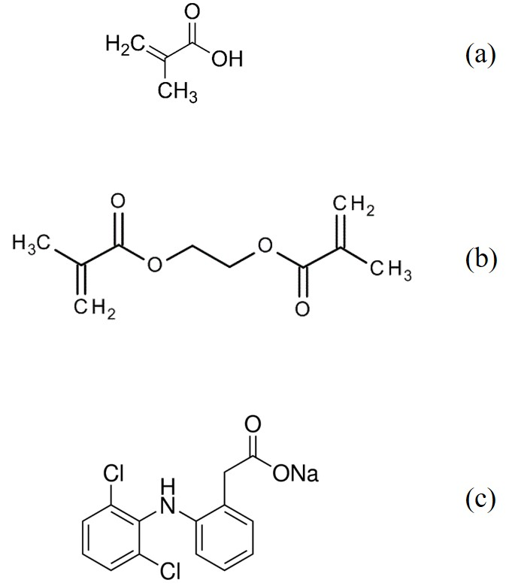
Fig. 1. Chemical structures of (a) methacrylic acid; (b) ethylene glycol dimethacrylate; (c) diclofenac sodium salt.

A few papers report on the use of MAA as functional monomer in combination with different cross-linker [36-38]. However, they described a synthesis by precipitation polymerization that needs more solvent and a longer procedure often requiring multiple steps. In our work, we have performed a timesaving synthetic strategy via a one-pot polymerization method.
3.2 Characterization
The TG and the corresponding DTG curves of MIP after the removal of the template (Fig. 2a) show the onset of degradation at 211° C and the maximum degradation rate temperature (MRDT) at ~ 390° C, with a shoulder centered at about 300°C. As well stated in the literature for the polymethacrylic acid, this step can be ascribed to the depolymerization via unzipping reactions starting from terminal groups. Indeed, the more prominent stage of degradation at higher temperatures is associated to the loss of water with formation of anhydrides [39]. For the MIP sample, it is possible to notice that the residue content is negligible, whereas the loss at around 82 °C suggests the presence of residual CH₃CN. In Fig. 2b the TG and DTG curves of the REF are reported; if compared to the MIP, the thermal profile indicates a slightly higher decomposition temperature (~ 400°C) with separate shoulders due to the different degradation stages. The inferior MRDT experienced from MIP (Fig.2a), suggests that DICLO molecules affect the polymerization reaction inducing lower molecular weight (MW). In light of this, we can reasonable suppose that the decrement in MW produces a shift of the thermal profile versus lower temperatures with shoulders overlapping as result.
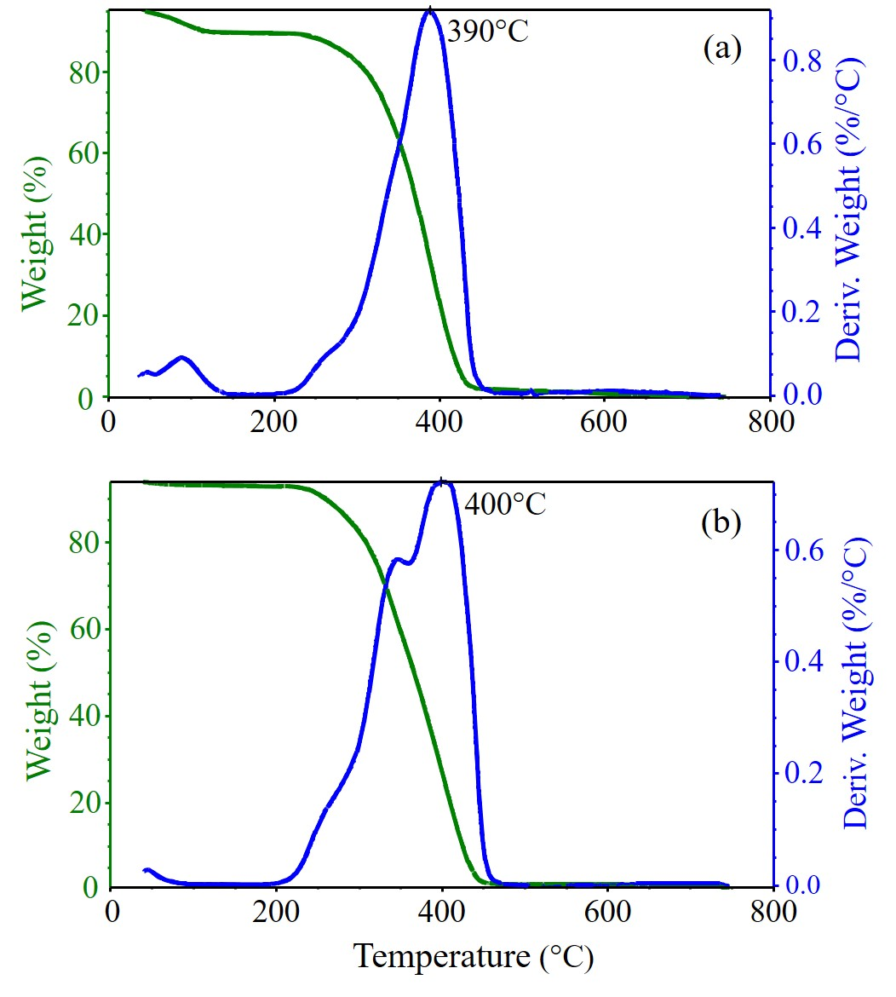
Fig. 2. TG and DTG curves of (a) MIP and (b) REF.

In order to detect the presence of DICLO, as well as to evaluate the volatile compounds formed during the first and the second stage of the polymer degradation, the pyrolysis of the MIP sample was carried out at 300° C and 600° C, respectively. The obtained pyrogram at 300° C for the MIP sample, just rinsed with deionized water to remove the unreacted species, is illustrated in Fig. 3a. The first peak (~ 4.8 min) is related to the initiator (AIBN), the most intense peak at ~ 11 min is ascribed to the EGDMA, whereas the peak at ~ 22.5 min is associated to DICLO, as evidenced to the mass spectra reported in the insets of the figure. After the washing procedure with methanol/acetic acid solution, the peak related to DICLO is not visible (Fig. 3b), evidencing the effectiveness of the washing procedure for the template removal from the polymer matrix. In this pyrogram, it is possible to clearly see only the peak related to EGDMA. An enlarged portion of the same pyrogram is reported in the supporting information (Fig. 1Sa), in which at ~ 1.5 min the peak related to the acetic acid, used for the washing procedure, is visible and at ~ 3 min the peak of the MAA, as illustrated in the mass spectrum reported in the inset. The obtained pyrogram at 600° C of the washed MIP sample, reported in the Fig. 1Sb, confirms the occurrence of the well-known degradation mechanism of methacrylic polymers via two steps depolymerization processes [40]. In the first step of MIP degradation, centered at about 300° C MAA and EGDMA preferentially evolved. The depolymerization is due to the presence of olefinic end groups, formed by disproportionation, producing the unzipping phenomenon. The second step of degradation preferentially leads to the same pyrolysis compounds; however, their origin take place through a chain scission depolymerization. In addition, due to the high temperature of pyrolysis (600° C) the monomers, especially the diacrylate, undergo further degradation reactions.
For the REF sample the obtained pyrogram (not reported) is identical to that of the MIP, indicating that the structures of the two polymers are the same.

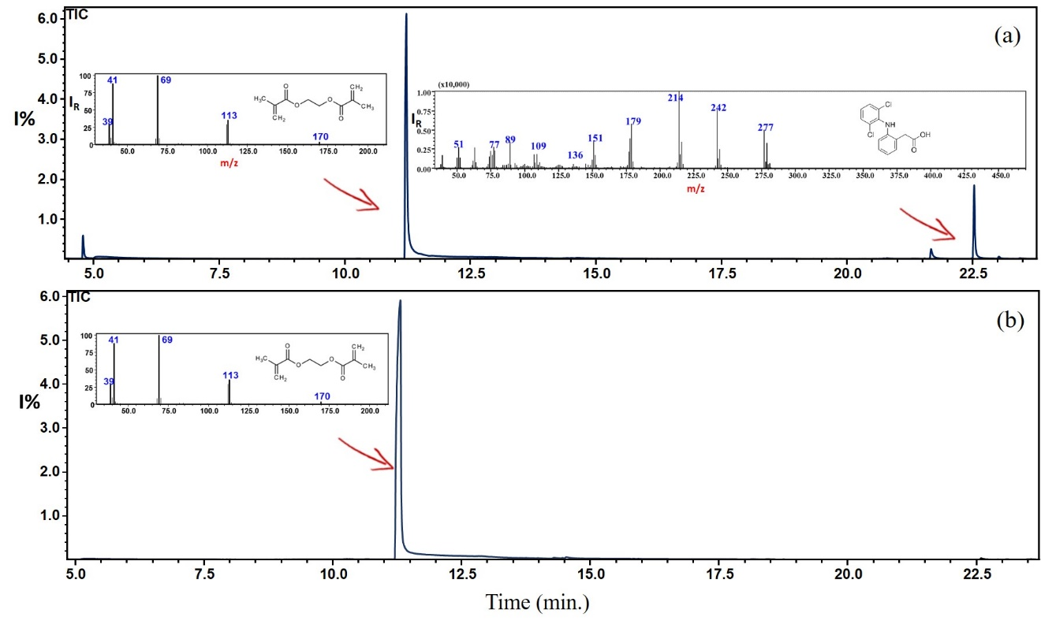
Fig. 3. Pyrogram of MIP at 300 °C (a) pre and (b) after washing procedure.

¹³C solid state nuclear magnetic resonance (NMR) spectra of REF and washed MIP samples were recorded to analyze their chemical structure (Fig. 4). Both spectra show the typical features of acrylic polymers, with main chain carbon signals at 45 and 55 ppm and carbonyl peak at 177 ppm, while the broad and complex band centered at 21 ppm is attributed to methyls of polymerized methacrylic/methacrylate groups [41]. The peak of glycol carbons of EGDMA can be observed at about 63 ppm. No significant differences were observed in main peak shape and position showing that the presence of diclofenac does not significantly influence the structure of the polymer. Moreover, no residual diclofenac (its spectrum is also reported as control) was evidenced in the spectrum of the MIP material confirming its effective removal during the washing process. In both MIP and REF samples, residual unreacted acrylic groups (probably chain terminals) are present, as indicated by the signals at 126 and 136 ppm and by the corresponding carbonyl peaks centered at 167 ppm. The amount of residual unreacted terminals, calculated comparing the area of the carbonyl peaks attributed to reacted and unreacted species, was about 4 mol% for both materials.
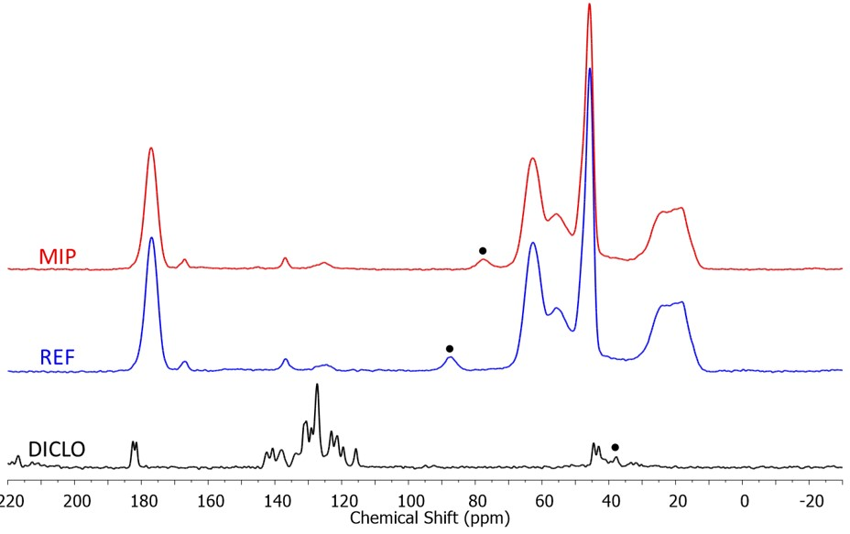
Fig. 4. ¹³C CP NMR spectra of REF and MIP. Spinning sidebands are marked by a dot. The spectrum of pure diclofenac (DICLO) is shown for comparison.

Gas adsorption volumetric analysis revealed that REF and washed MIP show type II isotherm (Fig. 5a) and a BET SSA of 320 ± 3 m²/g and 220 ± 4 m²/g, respectively. These values are in the range reported in the literature data for MIP based on MAA-EGDMA [33, 42]. In accordance with the higher SSA, REF presented higher total pore volume (0.51 cm³/g) than MIP (0.39 cm³/g). Both polymers presented a minor fraction of micropores centered at 1.6 nm, which constitutes 15 % of the total pore volume for REF and 14 % for MIP, and a major meso/macroporosity extending in the range 2-100 nm (Fig. 5b). The reduced pore volume of MIP with respect to REF could be ascribed to the interaction of DICLO molecules with MAA that could partially hinder the crosslinking. This finding further validates that the adsorption performances of our MIP are not due to the pore size distribution, but to the imprinting effect.
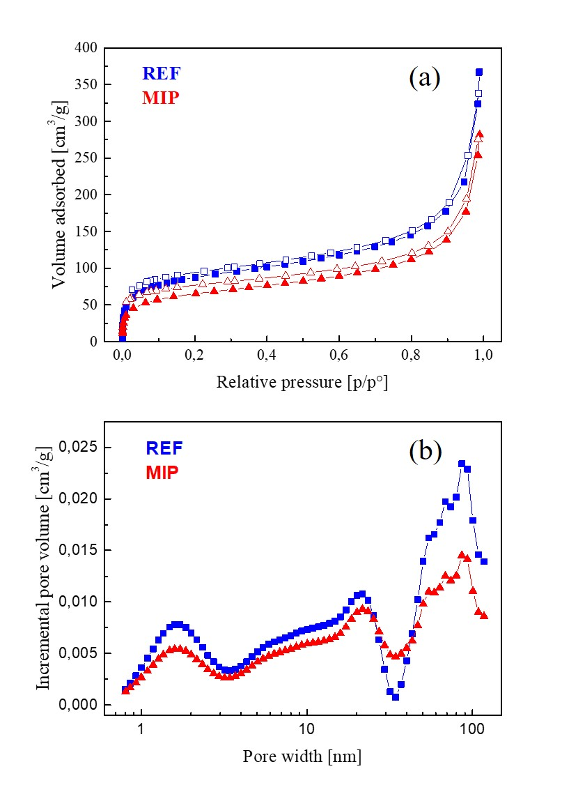
Fig. 5. Nitrogen adsorption (filled symbols) and desorption (empty symbols)
isotherms of REF and MIP (a), NLDFT pore size distribution of REF and MIP (b).

3.3 Adsorption properties
To investigate the adsorption performance of the synthesized imprinted and non-imprinted polymers, static batch binding tests were performed, using a standard solution of DICLO in deionized water at an initial concentration of 10⁻⁴ M, in which 5 mg of MIP and REF were dispersed, respectively. The variation in the diclofenac concentration was evaluated spectrophotometrically. Fig. 4 illustrates the absorption spectra of DICLO solutions after 10 minutes in contact with MIP and REF, compared to a blank solution, i.e. a diclofenac solution not in contact with the polymeric powders. No variation in the drug concentration was observed without the adsorbent material. Instead, it is evident that the diclofenac concentration is considerably reduced in the presence of MIP powder, proving that the adsorption of DICLO was significantly higher on the MIP than on the REF. In 10 minutes, 5 mg of MIP were able to remove ~ 90% of DICLO present in the solution, while only 8% was removed by the same quantity of REF. This phenomenon is an effect of the imprinting process; during the synthesis, indeed, most of the functional monomer molecules were orderly assembled around the DICLO molecules by electrostatic attraction and their positions were fixed by the polymerization. After removing the template, a molecular memory is introduced in the polymer matrix in which cavities complementary to DICLO molecules are present, consequently the polymer becomes able to recognize and rebind the template. On the contrary, the random distribution of functional monomers in the REF resulted in a lower binding affinity towards DICLO.
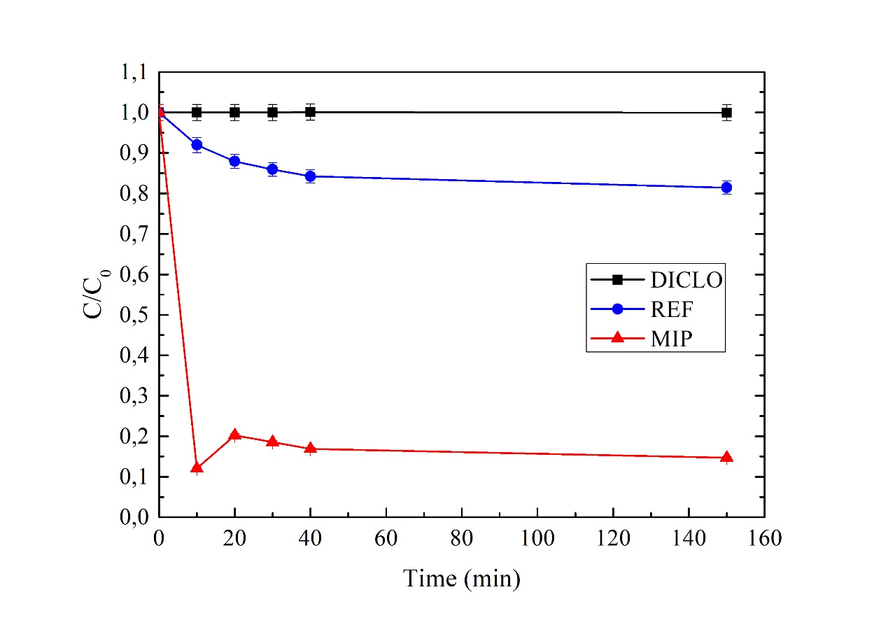
Fig. 6. Time profile of DICLO concentration (initial concentration: 32 mg/L) adsorbed by MIP (triangles) and REF (dots). A blank is also reported as control (squares) (lines are to guide the eye).

The adsorption kinetics of the polymers is depicted in Fig. 7, in which we report the variation in the drug concentration, proportional to the absorbance of the solution according to the Lambert-Beer law, as a function of the adsorption time. C is the concentration of DICLO after the adsorption and C₀ is the starting concentration of DICLO. We have measured the variation of the drug concentration in the absence of any adsorbent (squares), in the presence of 5 mg of MIP (triangles) and in the presence of 5 mg of REF (dots). As expected, for the blank no variation in the concentration was observed for the whole time of the test. A decreasing trend was observed for both MIP and REF; in particular, for MIP the decrease of the drug concentration is significant at the beginning of the adsorption test, the material was able to adsorb ~ 90% of drug in the first 10 minutes. As observed in the graph, after 20 minutes the MIP has released in the solution a small amount of the previously adsorbed drug, due to the mechanical shake of the solution that causes the release of the more weakly adsorbed DICLO molecules. Thereafter the system reaches its binding equilibrium. In comparison, REF adsorbed less than 10% of drug, reaching its binding equilibrium almost in the same time frame. The short time necessary to reach the binding equilibrium indicates that the adsorption process is very quick. The calculated Q_{e} confirms that the amount of DICLO adsorbed by MIP is significantly higher than DICLO adsorbed by REF, the obtained values are ~ 110 µmol/g for the MIP and ~13 µmol/g for the REF, respectively. In literature, we found that the Q_{e} obtained by De Oliveira et al. using organoclays as diclofenac adsorbents was 190 µmol/g [43], Bhadra et al. obtained a value of ~ 1500 µmol/g using oxidized activated carbon [44], the same value was also found by Liang et al. using amine-functionalized chitosan [45]. Despite our value is lower than the reported results in literature, the advantage of using our polymers lies in their selectivity and easily regeneration. These properties, not present in the traditional adsorbents, are essential for the realization of selective and cheap adsorbents and they are deeply investigated in the next sections.
The presence of DICLO molecules in the MIP after the adsorption test was also corroborated by GC-MS analysis as displayed in Fig. 8, in which the peak associated to DICLO is clearly visible at ~ 22.5 min.
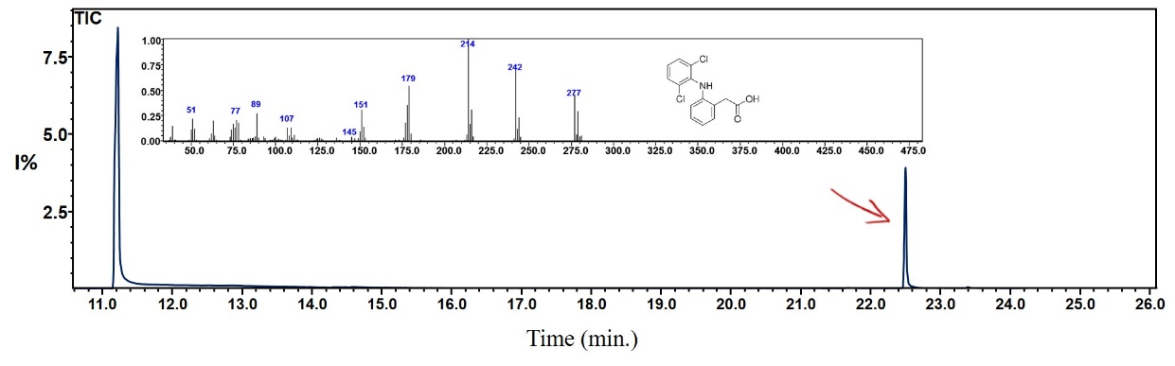
Fig. 7. Pyrogram of MIP at 300 °C after the adsorption of DICLO.

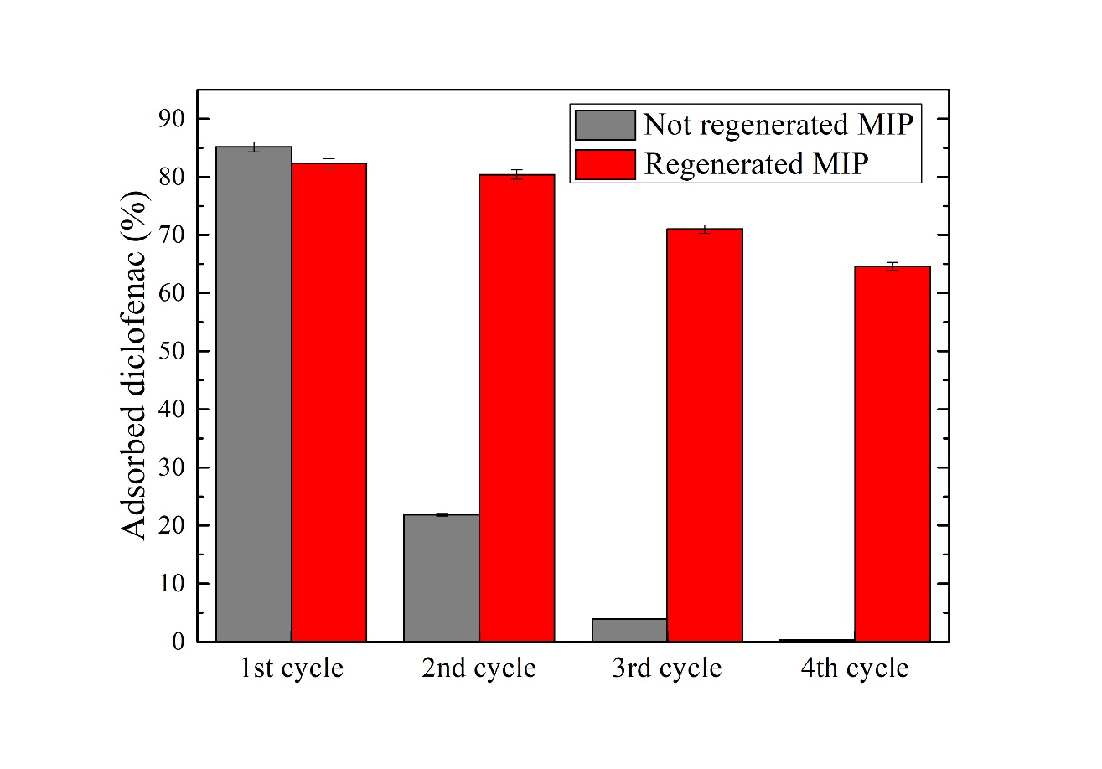
Fig. 8. Adsorption cycles by a not regenerated MIP (gray color) and a regenerated
MIP (red color). (For interpretation of the references to colour in this
figure legend, the reader is referred to the web version of this article.)

3.4 Regeneration of MIP
To evaluate the capacity of the MIP to be regenerated and reused, the adsorption performances after repeated cycles were investigated. After 10 min in the DICLO solution, the drug concentration was measured spectrophotometrically and the MIP powder was washed with 3 mL of methanol/acetic acid solution (9:1, v/v) for 2 min. Hence, it was submitted to further 10 min of adsorption. This procedure was repeated for four cycles, the results are illustrated in Fig. 9 and they are compared to the behavior of a not regenerated MIP powder. In this figure, the percentage of adsorbed diclofenac in 10 min due to the presence of regenerated and not regenerated MIP, respectively, is reported. The results clearly suggested that thanks to the regeneration process, the MIP can be efficiently reused as it preserves the adsorption capacity, whereas if the regeneration does not take place, after only three cycles the capacity to adsorb the drug was drastically invalidated. The observed slight decrease of the MIP adsorption performances is due to a gradual loss of powders during the washing steps. We have performed the desorption experiment also for the REF (not reported here). As done for the MIP, we compared the results obtained by the regenerated REF polymer, with the results of a not regenerated one. As expected, the washing procedure reactivates the adsorption properties of the polymer and the trend for the REF after washing is similar to the trend for MIP, while obviously its efficiency is much lower.
The proved reusability and easy regeneration of MIP for several adsorption/desorption cycles is a key factor for a large scale application as compared to some traditional adsorbent materials that are difficult to regenerate.
3.5 Adsorption selectivity
To investigate the specificity of the binding, the adsorption properties of the MIP and REF were tested in four different aqueous solutions containing: DICLO, ASA, TRIM and MO respectively, at the same concentration of 10⁻⁴ M. As evidenced by the results, reported in Fig. 10a, the adsorbed diclofenac by 5 mg of MIP in 10 min is significantly higher than the other compounds. Indeed, MIP is able to adsorb in the same time interval ~90% of DICLO, only ~10% of ASA, less than 3% of TRIM and ~23% of MO, despite this last compound has physicochemical properties similar to DICLO, like the anionic charge and the soil adsorption coefficient value (KOC). The same trend was not observed using REF as adsorbent (Fig. 10b). As expected, the adsorption capacity of the REF is lower than MIP, in addition it was not able to adsorb selectively the diclofenac. On the contrary it shows a slight preference to adsorb trimethoprim, probably do to the formation of several hydrogen bonding between the amine groups of TRIM and carboxylic groups of MAA.
We have evaluated also the adsorption capacity of MIP and REF in a mixture of DICLO and MO (Fig. 11). We have chosen to combine these two compounds, because their maximum absorption wavelengths are quite distant: 276 nm for DICLO and 646 nm for MO. This feature allows us to use the UV-vis spectrophotometer to evaluate the adsorption capacity. On the contrary, with TRIM or ASA this is not possible, being their maximum absorption wavelengths at 275 nm and 296 nm, respectively, to close for discriminating the spectrum features. The obtained results, reported below, reveal how also in a mixture MIP is able to adsorb preferentially DICLO than MO, despite the similar properties between this two compounds. MIP is able to adsorb in 10 min ~75% of DICLO and only ~ 37% of MO. For comparison, we have tested in the same conditions also the REF, that was able to adsorb only ~21% of DICLO and ~15% of MO.
The higher molecular recognition selectivity of MIP to its template suggests that imprinting cavities were successfully created during the polymerization process based on the interaction of size, shape, and functionality to the template molecules.
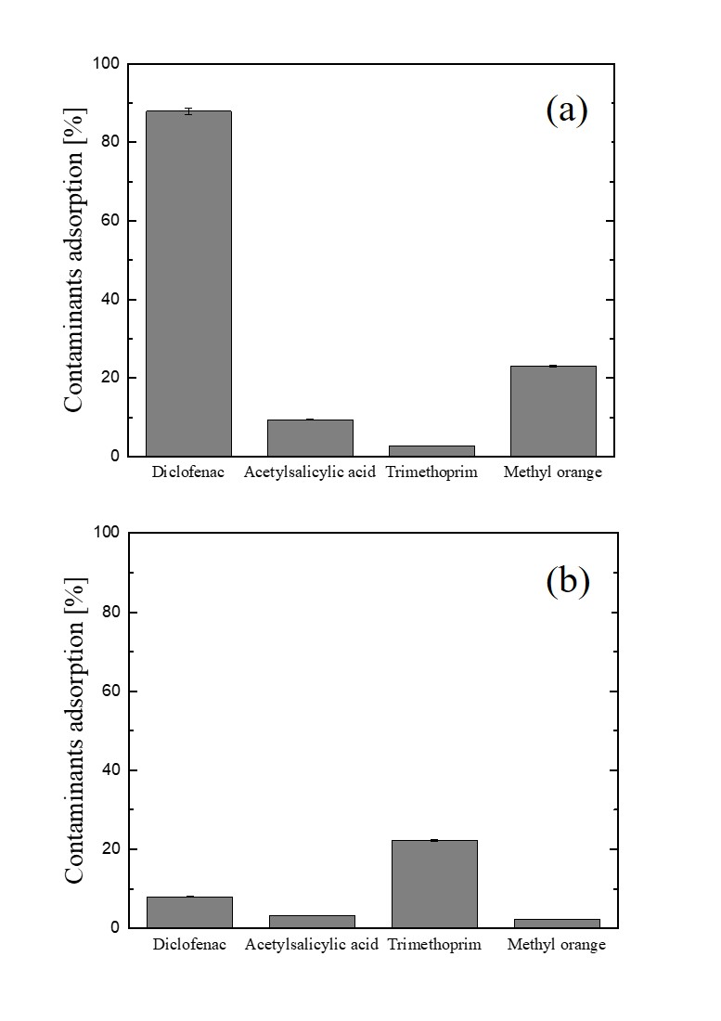
Fig. 9. Adsorption performance in 10 min of 5 mg of MIP (a) and REF (b), respectively,
towards four different organic compounds: diclofenac, acetylsalicylic acid, trimethoprim and methyl orange, respectively.
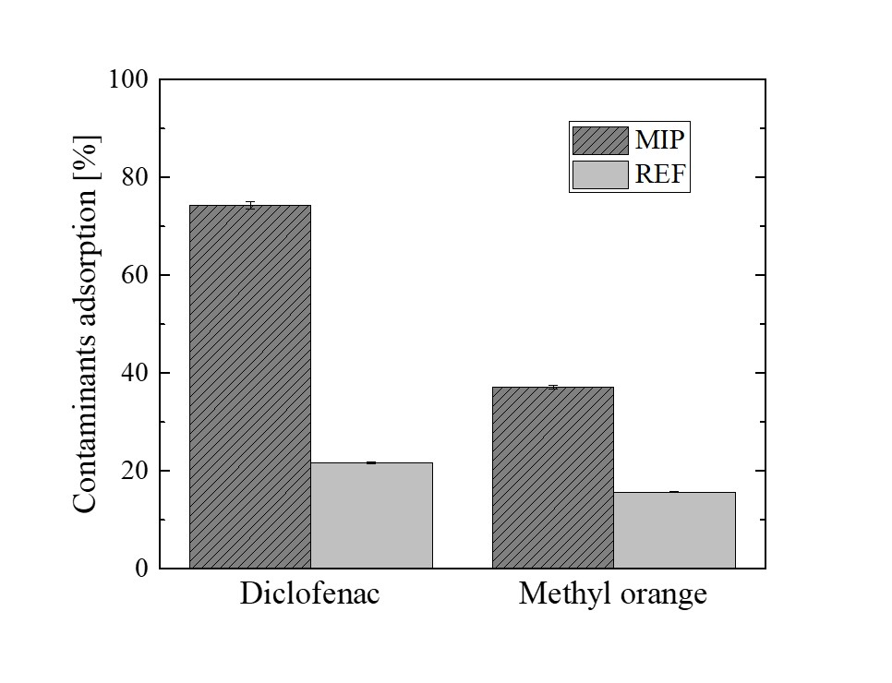
Fig. 10. Adsorption performance of MIP and REF in a mixture of diclofenac and methyl orange.

4. Conclusion
We have prepared by a simple bulk polymerization process a MIP able to adsorb selectively diclofenac from water. The rebinding abilities of the obtained MIP were compared with the abilities of a corresponding non-imprinted polymer (REF). In 10 minutes, 5 mg of MIP were able to remove ~ 90% of diclofenac from an aqueous solution, while only 8% was removed by the REF. If compared with the other synthetic procedures reported in literature, our synthetic pathway, being less time and solvent consuming, represents a valuable strategy to obtain MIP materials. In addition, the use of hydrophilic methacrylic acid as monomer, provides excellent material compatibility in water, overcoming one of the main limits of the traditional MIP. We demonstrated the extreme selectivity of the adsorption process and also the reusability of the material by performing several adsorption/regeneration cycles with an easy and quick procedure. The outstanding adsorption performances of the synthetized MIP for the selective removal of diclofenac from water suggested that our imprinted material might be successfully applied for water treatment even on a large-scale application.

Acknowledgements
The authors wish to thank Dr. Alessandro Di Mauro (CNR-IMM) for fruitful discussion, Giuseppe Pantè (CNR-IMM) and Carmelo Percolla (CNR-IMM) for the technical assistance.

References
- B. Petrie, R. Barden, B. K. Hordern, A review on emerging contaminants in wastewaters and environment: Current knowledge, understudied areas and recommendations for future monitoring. Water Res. 72 (2015) 3-27
- J.O. Tijani, O.O. Fatoba, O.O. Babajide, L.F. Petrik, Pharmaceuticals, endocrine disruptors, personal care products, nanomaterials and perfluorinated pollutants: a review, Environ. Chem. Lett. 14 (2016) 27-49
- L. Lonappan, S.K. Brar, R.K. Das, M. Verma, R.Y. Surampalli, Diclofenac and its transformation products: Environmental occurrence and toxicity – A review, Environ. Pollut. 96 (2016) 127-138
- T. Deblonde, C. Cossu-Leguille, P. Hartemann, Emerging pollutants in wastewater: a review of the literature, Int. J. Hyg. Environ. Health 214 (2011) 442-448
- M. Taheran, M. Naghdi, S.K. Brar, M. Verma, R.Y. Surampalli, Emerging contaminants: Here today, there tomorrow! Environ. Nanotechnol. Monit. Manage. 10 (2018) 122-126
- A.A. Basheer, New generation nano-adsorbents for the removal of emerging contaminants in water, J. Mol. Liq. 261 (2018) 583-593
- S. Kim, K.H. Chu, Y.A.J. Al-Hamadani, C.M. Park, M. Jang, D.H. Kim, M. Yu, J. Heo, Y. Yoon, Removal of contaminants of emerging concern by membranes in water and wastewater: A review, Chem. Eng. J. 335 (2018) 896-914
- L. Chen, X. Wang, W. Lu, X. Wu, J. Li, Molecular imprinting: perspectives and applications, Chem. Soc. Rev. 45 (2016) 2137
- M. Cantarella, A. Di Mauro, A. Gulino, L. Spitaleri, G. Nicotra, V. Privitera, G. Impellizzeri, Selective photodegradation of paracetamol by molecularly imprinted ZnO nanonuts, Appl. Catal. B 238 (2018) 509-517
- M. Cantarella, G. Impellizzeri, V. Privitera, Functional nanomaterials for water purification, Riv. Nuovo Cimento 40 (2017) 595-632
- S. Ansari, M. Karimi, Novel developments and trends of analytical methods for drug analysis in biological and environmental samples by molecularly imprinted polymers, Trends Analyt. Chem. 89 (2017) 146-162
- S.E. Diltemiz, R. Kecili, A. Ersoz, R. Say, Molecular imprinting technology in quartz crystal microbalance (QCM) sensors, Sensors 17 (2017) 454
- D. Xiao, Y. Jiang, Y. Bi, Molecularly imprinted polymers for the detection of illegal drugs and additives: a review, Microchim. Acta 185 (2018) 247
- J. Pan, W. Chen, Y. Ma, G. Pan, Molecularly imprinted polymers as receptor mimics for selective cell recognition, Chem. Soc. Rev. 47 (2018) 5574
- H. Marsh, F. Rodrìguez-Reinoso, Production and Reference Material, in: Activated Carbon. Elsevier Science Ltd, Oxford, (2006)
- F. Canfarotta, A. Poma, A. Guerreiro, S. Piletsky, Solid-phase synthesis of molecularly imprinted nanoparticles, Nat. Protoc. 11 (2016) 443-455
- A. Speltini, A. Scalabrini, F. Maraschi, M. Sturini, A. Profumo, Newest applications of molecularly imprinted polymers for extraction of contaminants from environmental and food matrices: A review Anal. Chim. Acta 974 (2017) 1-26
- O.M. Rodriguez-Narvaez, J.M. Peralta-Hernandez, A. Goonetilleke, E.R. Bandala, Treatment technologies for emerging contaminants in water: a review, Chem. Eng. J. 323 (2017) 361-380
- D.L. Huang, R.Z. Wang, Y.G. Liu, G.M. Zeng, C. Lai, p. Xu, B.A. Lu, J.J. Xu, C. Wang, C. Huang, Application of molecularly imprinted polymers in wastewater treatment: a review, Environ. Sci. Pollut. Res. 22 (2015) 963-977
- X. Shen, C. Xu, L. Ye, Molecularly imprinted polymers for clean water: analysis and purification, Ind. Eng. Chem. Res. 52 (2013) 13890-13899
- G.Z. Kyzas, D. N. Bikiaris, N. K. Lazaridis, Selective separation of basic and reactive dyes by molecularly imprinted polymers (MIPs), Chem. Eng. J. 149 (2009) 263-272
- W. Chen, M. Xue, F. Xue, X. Mu, Z. Xu, Z. Meng, G. Zhu, K.J. Shea, Molecularly imprinted hollow spheres for the solid phase extraction of estrogens, Talanta 140 (2015) 68-72
- R. Garcia, N. Martins, E.P. Carreiro, M. Simoes, M.M.L. Ribeiro Carrott, P.J.M. Carrott, A.J. Burke, M.J. Cabrita, Development of a selective sorbent for the solid-phase extraction of terbuthylazine in olive oil samples: a molecular imprinting strategy, J. Sep. Sci. 38 (2015) 1204-1212
- S. Alsudir, Z. Iqbal, E.P.C. Lai, Competitive CE-UV binding tests for selective recognition of bisphenol A by molecularly imprinted polymer particles, Electrophoresis 33 (2012) 1255-1262
- L.M. Madikizela, N.T. Tavengwa, L. Chimuka, Applications of molecularly imprinted polymers for solid-phase extraction of non-steroidal anti-inflammatory drugs and analgesics from environmental waters and biological samples, J. Pharm. Biomed. Anal. 147 (2018) 624-633
- C.M. Dai, J. Zhang, Y.L. Zhang, X.F. Zhou, Y.P. Duan, S.G. Liu, Selective removal of acidic pharmaceuticals from contaminated lake water using multi-templates molecularly imprinted polymer, Chem. Eng. J. 211-212 (2012) 302-309
- C.M. Dai, S.U. Geissen, Y.L. Zhang, Y.J. Zhang, X.F. Zhou, Selective removal of diclofenac from contaminated water using molecularly imprinted polymer microspheres, Environ. Pollut. 159 (2011) 1660-1666
- C.M. Dai, X.F. Zhou, Y.L. Zhang, S.G. Liu, J. Zhang, Synthesis by precipitation polymerization of molecularly imprinted polymer for the selective extraction of diclofenac from water samples, J. Hazard. Mater. 198 (2011) 175-181
- S. Azodi-Deilami, A.H. Najafabadi, E. Asadi, M. Abdouss, D. Kordestani, Magnetic molecularly imprinted polymer nanoparticles for te solid-phase extraction of paracetamol from plasma samples, followed its determination by HPLC, 181 (2014) 1823-1832
- V. Manzo, K. Ulisse, I. Rodriguez, E. Pereira, P. Richter, A molecularly imprinted polymer as the sorptive phase immobilized in a rotating disk extraction device for the determination of diclofenac and mefenamic acid in wastewater, Anal. Chim. Acta 889 (2015) 130-137
- L.M. Madikizela, L. Chimuka, Synthesis, adsorption and selectivity studies of a polymer imprinted with naproxen, ibuprofen and diclofenac, J. Environ. Chem. Eng. 4 (2016) 4029-4037
- I.A. Nicholls, K. Adbo, H.S. Andersson, P.O. Andersson, J. Ankarloo, J. Hedin-Dahlstrom, P. Jokela, J.G. Karlsson, L. Olofsson, J. Rosengren, S. Shoravi, J. Svenson, S. Wikman, Can we rationally design molecularly imprinted polymers? Anal. Chim. Acta 435 (2001) 9-18
- M.A. García Mayor, G. Paniagua González, R.M. Garcinuño Martínez, P. Fernández Hernando, J.S. Durand Alegría, Synthesis and characterization of a molecularly imprinted polymer for the determination of spiramycin in sheep milk, Food Chem. 221 (2017) 721-728
- X.H. Wang, L.F. Xie, Q. Dong, H.L. Liu, Y.P. Huang, Z.S. Liu, Synthesis of monodisperse molecularly imprinted microspheres with multi-recognition ability via precipitation polymerization for the selective extraction of cyromazine, melamine, triamterene and trimethoprim, J. Chromatogr. B 1007 (2015) 127-131
- M. Hassanzadeh-Khayyat, E.P.C. Lai, K. Kollu, B. Ormeci, Degradation of diclofenac in molecularly imprinted polymer submicron particles by UV light irradiation and HCl acid treatment, J. Water Resource Prot. 3 (2011) 643-654
- S. Noee, N. Salimraftar, M. Abdouss, G. Riazi, Imprinted microspheres and nanoparticles with diclofenac sodium: effect of solvent on the morphology and recognition properties, Polym. Int. 62 (2013) 1711-1716
- A.A. Pedpani, A.M.H. Shabani, S. Dadfarnia, S. Khodadoust, Solid pase microextraction of diclofenac using molecularly imprinted polymer sorbent in hollow fiber combined with fiber optic-linear array spectrophotometry, Spectrochim. Acta A 147 (2015) 26-30
- N. Salimraftar, S. Noee, M. Abdouss, G. Riazi, Z. M. Khoshhesab, Three-level response surface full-factorial design: advanced chemometric approach for optimizing diclofenac sodium-imprinted polymer, Polym. Bull. 71 (2014) 19-30
- D.H. Grant, N. Grassie, The thermal decomposition of polymethacrylic acid, Polymer 1 (1960) 125-134
- S. Tsuge, H. Ohtani, C. Watanabe, Pyrolysis-GC/MS Data Book of Synthetic Polymers, Elsevier (2011)
- R. Avolio, G. Gentile, M. Avella, D. Capitani, M.E. Errico, Synthesis and characterization of poly(methylmethacrylate)/silica nanocomposites: study of the interphase by solid state NMR and structure/properties relationships, J. Polym. Sci. Pol. Chem. 48 (2010) 5618-29
- D.A. Spivak, Optimization, evaluation, and characterization of molecularly imprinted polymers, Adv. Drug Deliv. Rev. 57 (2005) 1779-1794
- T. De Oliveira, R. Guégan, T. Thiebault, C. Le Milbeau, F. Muller, V. Teixeira, M. Giovanela, M. Boussafir, Adsorption of diclofenac onto organoclays: Effects of surfactant and environmental (pH and temperature) conditions, J. Hazard. Mater. 323 (2017) 558-566
- B. N. Bhadra, P. W. Seo, S. H. Jhung, Adsorption of diclofenac sodium from water using oxidized activated carbon, Chem. Eng. J. 301 (2016) 27-34
- X. X. Liang, A.M. Omer, Z.H. Hu, Y.G. Wang, D. Yu, X.K. Ouyang, Efficient adsorption of diclofenac sodium from aqueous solutions using magnetic amine-functionalized chitosan, Chemosphere 217 (2019) 270-278

